CS-248 Assignment Web 5 PHP Address Processing (50 points)

Due: Tuesday March 7th by class time e-mail to masont@uwstout.edu.

Submission: E-mail me the link to your form (html) program on mscs-php.uwstout.edu at masont@uwstout.edu. Your links must start with mscs-php.uwstout.edu/

This project uses the form provided to submit the parameters for an address to a new PHP file that you will create. The next assignment will build on these concepts to process in PHP a full web order form.
- Update the provided html webpage Web5AddressForm.html with the following items:
  - Title that includes your name in a header. Replace “Your name”
  - Save in a folder that will map to the server. (Folder set up in Dreamweaver.)
  - Preview in Dreamweaver to put file to the server.
- Create a PHP file in the same directory as the Web5AddressForm.xhtml file. This must be in a directory that Dreamweaver will publish to server. The form should now be directed to (action) this newly created PHP page.
  - Update xhtml tag for form with action to your new file.
    - <form action="yourfile.php" method="get" > (10 points)
  - The page should complete the following things when passed the data. (20 points)
    - Print out the received data in the $_GET array.
    - Print out the street, city, state and zipcode
748 Wheaton Road
DeKalb, IL 60115

  - Validate the data in the PHP code. (20 points)
    - Confirm that street, city, and state all are set and have length greater than 1.
    - Confirm that zip code has a length of 5 characters.
    - If any of these things fail, put in a link back to the html form with a nice request to complete the form properly.

Example form and submitted data:

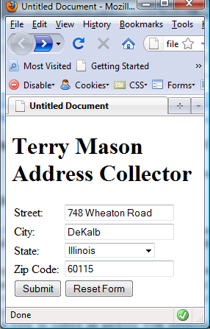
Error: Return to your form to complete the data and make sure that your zipcode has 5 digits.
748 Wheaton Road
DeKalb, IL 60115

